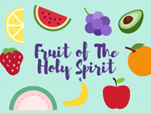
VBS August 8-12, 2022 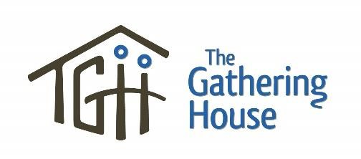

Name of Child: ____________________________________________________ Age: __________
Date of Birth: __________________________________ Grade in September _________________________
Gender: _________ Address: __________________________________________________________ Medical Information
Health Card #: __________________________________ Doctor’s Name _____________________________
Please indicate any special needs, allergies, health conditions (diabetes, behavioural concerns, etc.) or other pertinent medical or behavioural information. We welcome children with special needs but do ask that a parent/guardian accompany them. Please contact tghchristinakozmin@gmail.com for more info
____________________________________________________________________________________

Parent or Guardian: ___________________________________ Relationship: _________________________
Phone: __________________ Other:__________________ e-mail___________________________________
Secondary Contact: _______________________________ Phone: ______________________

Important Notes:
Fruit of the Spirit VBS Grades 1-6
August 8-12
9am-Noon
$10 per Child
Please bring a water bottle labelled with child’s name

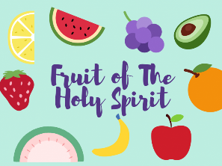
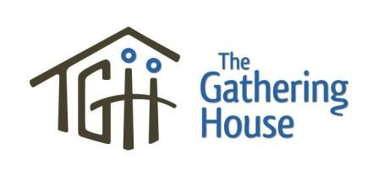
Required Signatures

Permission to Participate
I, the legal guardian or custodial parent of __________________________________, give my permission for
Name of Child
him/her to participate in Gathering House Camp

_______________________________________ ______ ___________________________
Name of Parent/Guardian (please print) Date

_____________________________________________________________________
Signature of Parent/Guardian

Medical Release and Waiver
In the event that my child requires special medication, x-rays, or medical treatment, I understand that I will be notified immediately. In the event that I am not able to be contacted and my child requires immediate medical treatment, I give permission to the physician selected by The Gathering House to hospitalize and/or provide proper medical treatment to my child. I understand that this could include injections, anaesthesia, or surgery.

Waiver
Understanding that precautions are taken for the safety and health of my child while participating in
Gathering House VBS, I hereby release from any liability The Gathering House, its staff and its volunteers in the event of sickness or injury incurred by my child during this program.

_______________________________________ ______________________________
Signature of Parent/Guardian Date

Photos
I give permission to The Gathering House to publicly use any photos in which my child appears to highlight our events and promote future events (website, posters, displays etc.)

_______________________________________ ________________________________
Signature of Parent/Guardian Date

